**EXPERIMENT-4**

Name: K.Sriya

Roll No: 2320090043

Aim: Construction of Different VLANS and TRUNKING using cisco packet tracer.

Apparatus Required:

* Two 2950 Switches
* 8 PCs
* Copper straight through cable
* Cross-over cable

Procedure:

Step 1: Open Cisco Packet Tracer.

Step 2: To construct VLANs trunking.

Step 3: 2 Switches, 8 PCs

* Connect PC 1, 2, 3, 4 to Switch 1.
* Connect PC 5, 6, 7, 8 to Switch 2.
* Connect Switch 1 and Switch 2 with a cross-over cable. Connect fa0/24 of s1 to fa0/24 of s2.

Step 4: Switch 1 configuration.

Step 5: Switch 2 configuration.

Step 6: Check trunk ports and check VLANs.

Step 7: Assign IP addresses to PCs:

* PC 1, 2, 5, 6: VLAN 10
* PC 3, 4, 7, 8: VLAN 20

Step 8: Ping PC1 to PC2 (both in VLAN 10).

Ping PC1 to PC7 (time out).

Result:

Switch 1 configuration Switch > enable

Switch # configure terminal (config) # vlan 10

(config-vlan) # name VLAN10 (config-vlan) # exit

(config) # vlan 20

(config-vlan) # name VLAN20 (config-vlan) # exit

(config) # interface range fa0/1-4

(config-if-range) # switchport mode access

(config-if-range) # switchport access vlan 10 (config-if-range) # exit

(config) # interface range fa0/5-8

(config-if-range) # switchport mode access

(config-if-range) # switchport access vlan 20 (config-if-range) # exit

(config) # interface fa0/24

(config-if) # switchport mode trunk (config-if) # exit

Same do as Switch 2 configuration Check Trunk Ports:

Switch # show interfaces trunk

Port VLAN Mode Encapsulation Status Native fa0/24 on 802.1q trunking

Port VLANs allowed on trunk fa0/24 1-1005

Port VLANs allowed and active in management domain fa0/24 1, 10, 20

Post pruned VLANs in spanning tree forwarding state fa0/24 and not 1, 10, 20

Switch > show vlan brief

VLAN Name Status Port

1 default active Fa0/9, Fa0/10, Fa0/1, Fa0/12,

Fa0/13, Fa0/14, Fa0/15, Fa0/16, Fa0/18, Fa0/19, Fa0/21, Fa0/22,

Fa0/23, Fa0/24

10 VLAN10 active Fa0/1, Fa0/2

20 VLAN20 active Fa0/3, Fa0/4 1002 fddi-default active

1003 token-ring-default active

1004 fddinet-default active

1005 trnet-default active

Switch 0 configuration

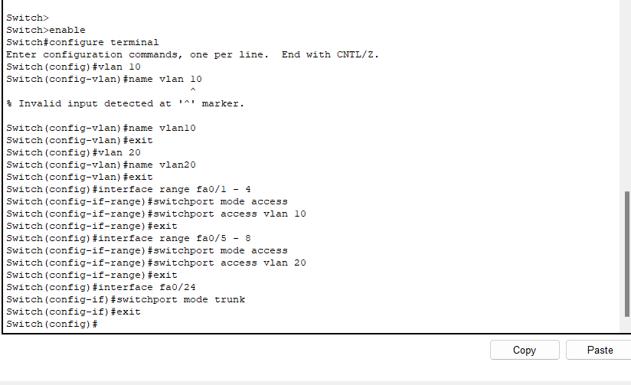

Switch 1 configuration

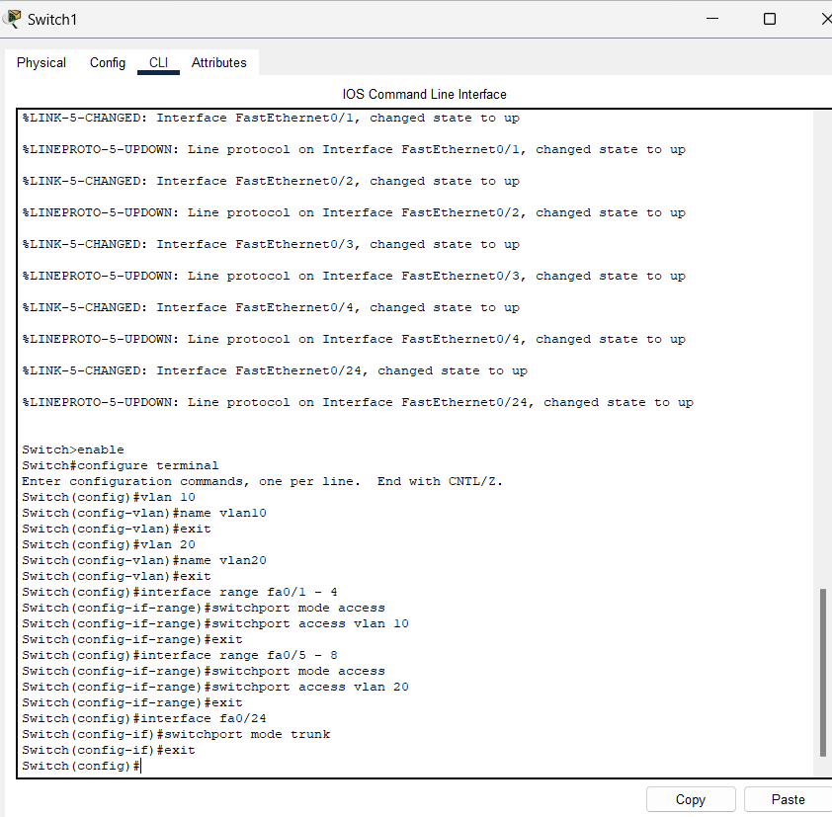

1. **Check Trunk Ports:**

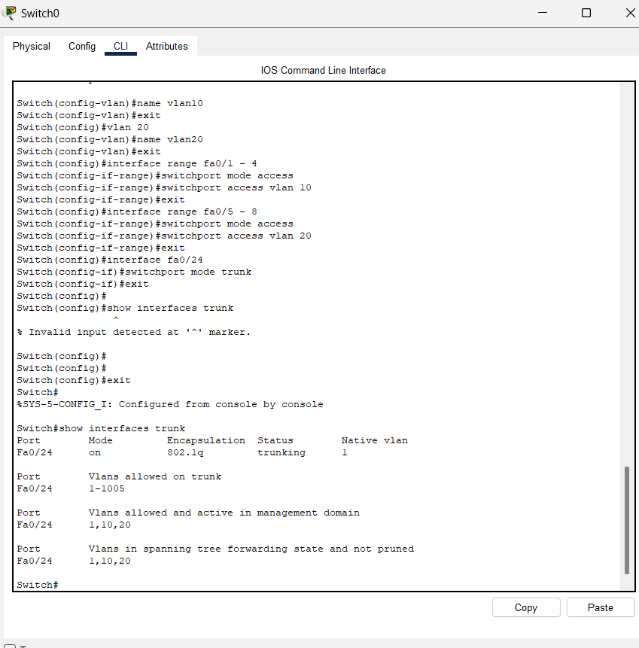

Check VLANs:

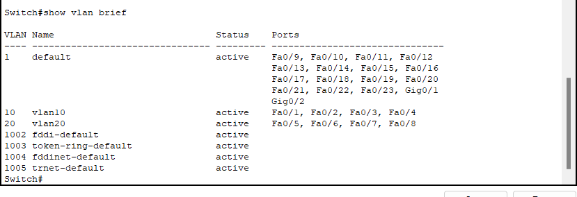

1. Assign IP Addresses to PCs:

For pc1

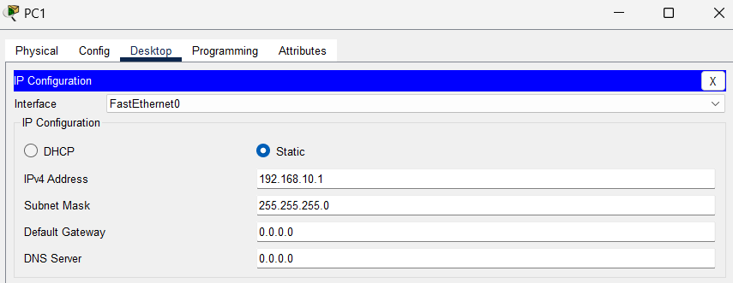

For pc2

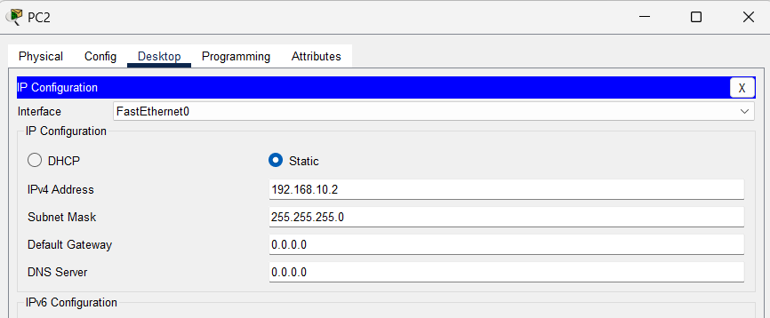

For pc 3

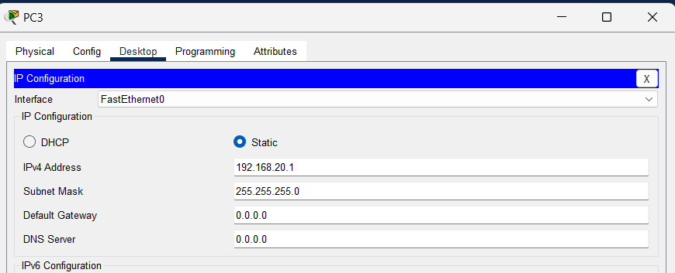

For pc4

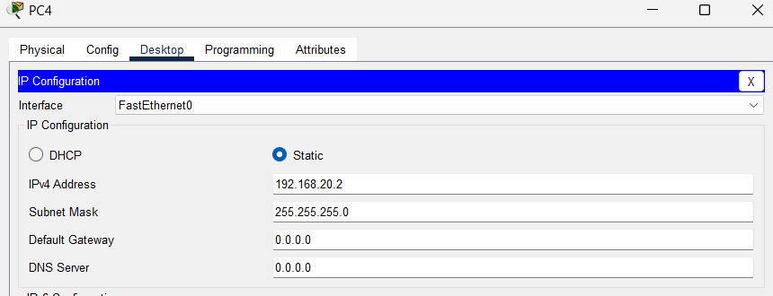

For pc5

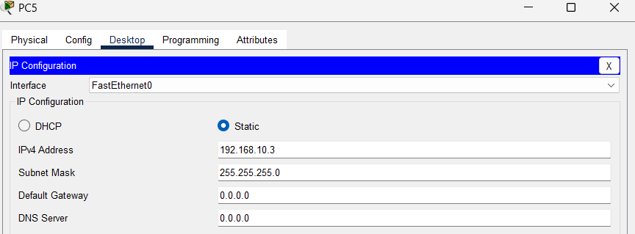

For pc6

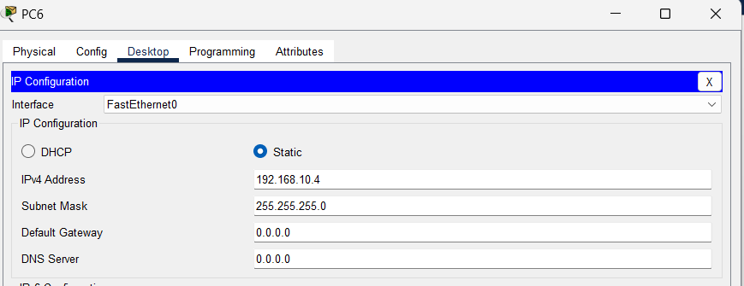

For pc7

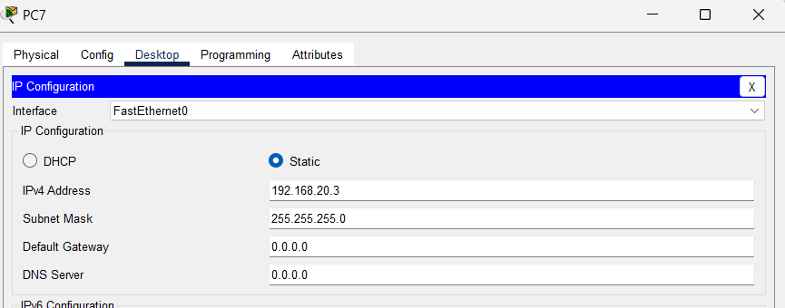

For pc8

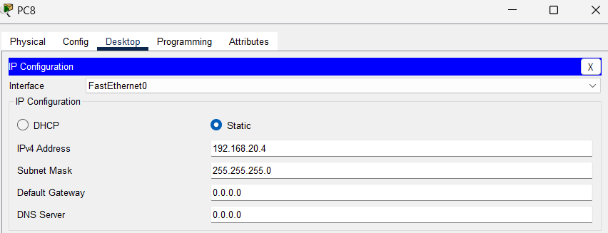

Now **Ping** from **PC1** to **PC2** (both in VLAN 10)

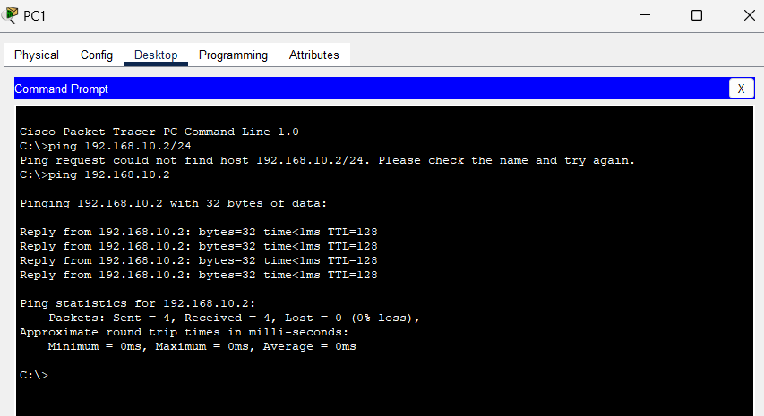

**Ping** from **PC3** to **PC4** (both in VLAN 20)

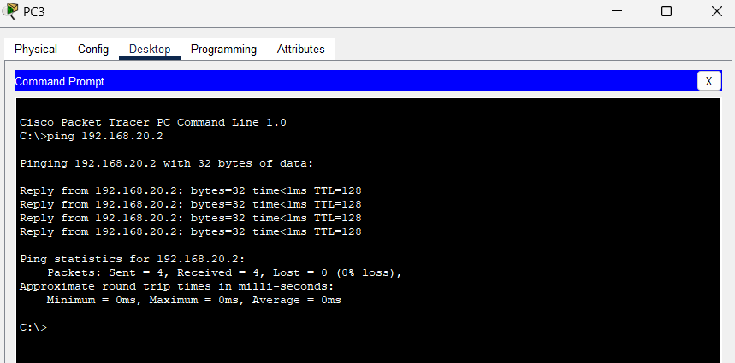

**Ping** from **PC5** to **PC1** (both in VLAN 10, across switches)

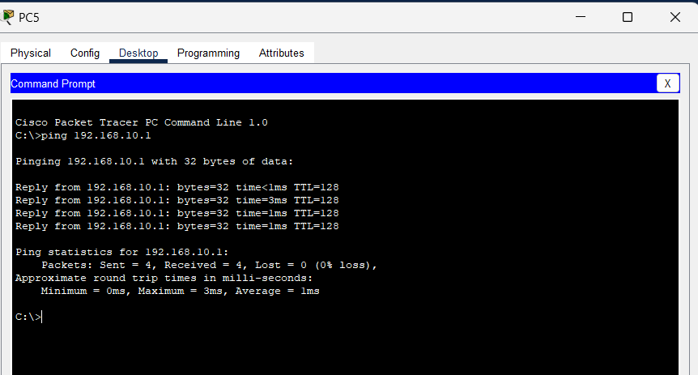

**Ping** from **PC7** to **PC3** (both in VLAN 20, across switches)

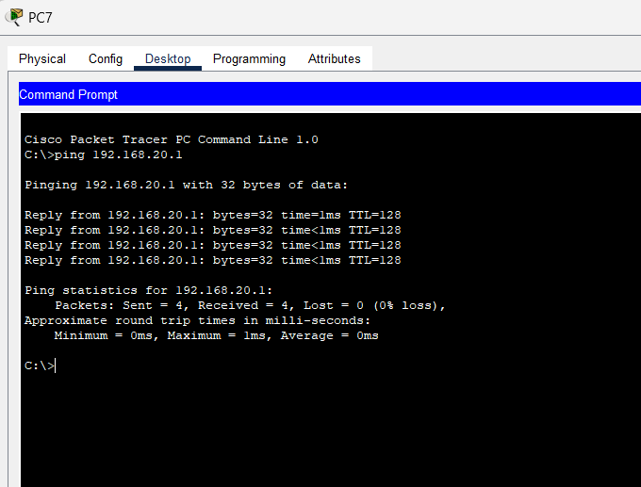

Verify **that PCs in different VLANs cannot communicate without a router: Ping** from **PC1** to **PC3** should fail (VLAN 10 to VLAN 20)

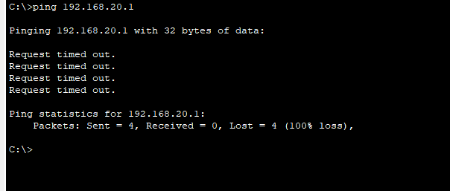

Ping from PC7 to PC1

